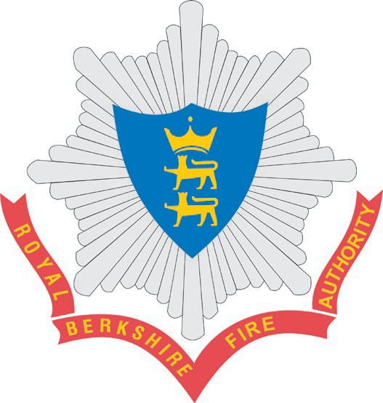
Headquarters, Newsham Court, Pincents Kiln, Calcot, Reading, RG31 7SD

Dear Resident,

Royal Berkshire Fire Authority Budget and Council Tax Consultation 2023/24

Royal Berkshire Fire and Rescue Service’s annual budget for 2022/23 is £38.4 million. Just over two thirds of funding comes from council tax, the other sources of income being Government grants and business rates.

Like all public services we are committed to delivering value for money across the services we provide. Our drive to improve efficiency has delivered over £2.4 million in savings since 2016 and we are rated as a ‘good’ fire and rescue service in terms of efficiency and effectiveness by His Majesty’s Inspectorate of Constabulary and Fire & Rescue Services.

Whilst we have been able to use some of the savings made to invest in the vital services that we provide to the public, we have also had to reduce expenditure in certain areas to balance our budget. Our drive to improve efficiency continues as we put in place more effective ways of working through the use of technology as well as seeking other savings for 2023/24.

Nevertheless, the high rate of inflation means that we are now having to deal with significant unbudgeted cost pressures that have materialised over the last year. In addition to pay pressures we are facing substantial increases in the costs of goods and services that we procure, all of which means that we are facing a projected deficit of £800,000 by the end of 2022/23.

As part of its plan to balance the budget for 2023/24, Royal Berkshire Fire Authority will deliver a significant programme of savings next year. However, this will still leave the Fire Authority with a large funding shortfall for 2023/24, which means I am recommending that we raise the Band D precept by £5 per annum to £78.95 in order to maintain current service levels to the public. This will most likely still leave the Authority in the lowest quartile of precepting fire authorities in the country.

As Chair of the Fire Authority, I am acutely aware of the financial pressures that all residents have to contend with. It is therefore important for you to know that the Fire Authority is committed to delivering excellent services and good value for money.

I should be grateful if you could take part in our online survey or visit rbfrs.co.uk/haveyoursay to let us know your views. The consultation closes on 30 January 2023.

Yours faithfully,

Councillor Paul Gittings
Chair of Royal Berkshire Fire Authority

